WildLog

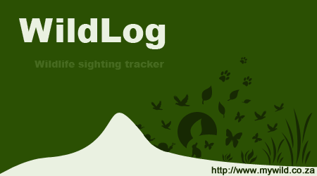
User Guide
v6

May 2019
Henry de Lange
Table of Contents
Introduction 3
Background 3
Concepts 4
Data Storage and Workspaces 4
User Interface Basics 5
Tool-tips 5
Tips for Basic Interaction 5
Drag-and-Drop 5
Special Actions 5
Home Screen 6
Creating and Changing Workspaces 6
Progress Bar 6
Menu Overview 7
Settings Overview 8
Browse Tab 9
Places Tab 10
Creatures Tab 10
Observations Tab 11
Place Details Tab 12
Period Details Tab 13
Observation Details Dialog 14
Creature Details Tab 15
Bulk Import Tab 16
Workspaces 17
Workspace Data And Uploaded Files 17
Insuring Workspace Integrity 17
Creating And Changing Workspaces 17
Opening One or More Workspaces 17
Problems Opening A Workspaces 17
Backup And Restore 18
Export 18
Import 20
Import From CSV 20
Import From IUCN Species Lists 20
Import From Another Workspace 20
Import From WildNote 20
Bulk Import 20
Import From iNaturalist 20
Advanced Features 21
Slideshow Videos 21
Maps 22
Distribution and Heat Maps 23
Custom Layers 26
Charts 28
Observation Filters 30
Sun and Moon Phase 31
Extra Features 31
WildNote Integration 32
Export Data From WildLog To WildNote 32
Import Data From WildNote Into WildLog 32
iNaturalist Integration 33
Cloud Sync 35
Check And Clean Workspace 36
Additional Information 36
The Future of WildLog 36
Contact Information 36
Minimum System Requirements 37

Introduction

The goal of this guide is to help you get started using WildLog.

WildLog is designed with the idea of making basic features easily accessible and simple to use, but it also provides some more advanced functionality for experienced users.

WildLog provides a fixed framework for storing and working with wildlife observation data. How to best make use of this framework is up to you. WildLog stores location, species and onservation information in a Workspace. You can create multiple Workspaces, thus allowing you additional freedom to use the framework to best fit your needs. WildLog also has the ability to export your data (in various formats) for easy integration with external tools.

The rest of this guide will explain how to use WildLog and cover some of the basic functionality. The best way to learn is to download the application and try it for yourself. You can create a Workspace and play around with the various features. You can then create a new Workspace when you are ready to start capturing your real data.

Background

WildLog was created by Henry de Lange (myself) in 2008 to help keep track of my wildlife sightings. I wanted to have an offline database where I could record what I saw while on vacation that isn't dependent on an internet connection or a third party service provider, but offered more than a simple spreadsheet or a folder full of photographs.

Over the years I have continued to expand the functionality of WildLog and even added some features aimed at my camera trapping hobby. The primary audience for the application is still myself. However, I've put a lot of work into this project and I really hope that this software can also be helpful to other people out there as well.

The application is a work in progress and I continually add new features. I try to make updates available online from time to time.

This is not a “commercial application” and I work on the project in my spare time and at my own expense, although some features have been custom developed for paying clients.

Use the software at your own risk. I use this application extensively myself and try to keep it as up to date and bug free as possible. Because I wrote the software myself I know how it should be used, and don't always foresee how it could be used by other people. If you experience any problems or have any questions please let me know at support@mywild.co.za .

Note: I live in South Africa, as a result the application is designed in that context, however I’m sure it can easily be used in other parts of the world as well.

Concepts

The primary goal of the software is to allow you to log Observations of Creatures at certain Places during a specific Period. In order to do this each Place can have multiple Periods, and each Period can have multiple Observations. Each Observation is thus linked to one Place, one Period and one Creature. The main concept to understand is that Places and Creatures are the foundations of your data, and Observations are the building blocks. Periods are the glue that groups related Observations together.

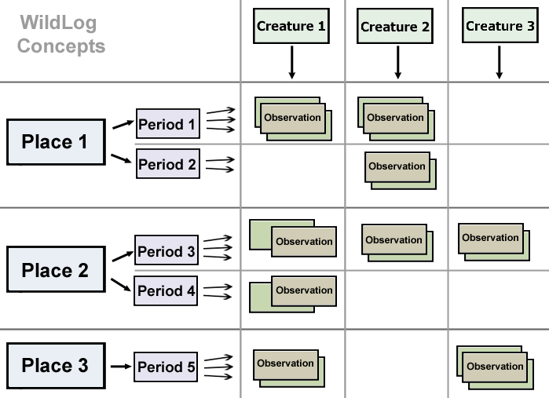
Example
I'm visiting Kruger National Park for the first time and I see some Impala and Zebra next to the road. In WildLog I add Kruger National Park as a new Place.
I then create a new Period for Kruger National Park and add information and photos about my current trip to the Period.
Since this is the first time I'm recording Impala in my WildLog Workspace I have to add a new Creature called Impala.
I can now add an Observation for the Impala to the Period, and then add another Observation for the Zebra as well.
If I've recorded the GPS location I can enter it as well, allowing me to view the exact location where the sighting was using WildLog's built in maps.

There are many other ways of using the software, but the above illustrates the general case for which the application was designed.

Data Storage and Workspaces

Each new Workspace starts out with a default Place, Period and Creature. It can take a while to build up a list of Places and Creatures. Luckily once added they can be easily reused. If you frequently find yourself starting new Workspaces, then you can consider creating a clean start-up Workspace which already contains all the common Creatures and a default Place and Period for convenience. Using the Workspace Import / Export features makes this easy. You can also import species names from a CSV file available from the IUCN Red List website.

User Interface Basics
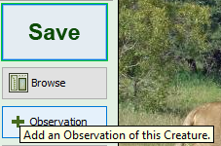

Tool-tips

Most buttons and user interface controls have a tool-tip message that provides additional information regarding the action that will be performed when pressed. Simply hover the mouse pointer over a component to see the tool-tip.

Tips for Basic Interaction

- You can can click on the image-boxes that display the linked files to open the original file.
- Most pop-up windows and dialogs can be quickly closed using the Escape key.
- Multiple table rows can be selected, where allowed, by clicking and dragging on the table or by holding the Shift or Ctrl key while selecting a row. Pressing the up or down keys will change the selected row and pressing the 'Enter' key will open it.
- You are able to find a specific row in a table by selecting any row and then starting to type the name of the value (from the first column) you want to find.
- Table rows can be sorted by clicking on the relevant column header, clicking again will reverse the sort order.
- The columns can be re-sized by click-and-dragging the column separator.
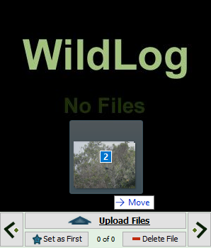
- You can navigate between many open tabs by right clicking on the tab header and then selecting the tab from the list or use the mouse wheel. Using the mouse middle-click will close a tab.

Drag-and-Drop

On supported operating systems you will be able to drag files from your computer (outside WildLog) and drop them onto designated areas inside the WildLog application. This will then perform some action on the file(s). The most common use of this functionality is to easily upload new files to Places, Creatures, Periods and Observations by simply dropping them on the large image-box at the top right corner of the screen.
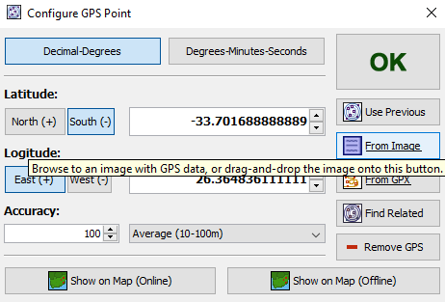

Special Actions

Some buttons in WildLog provide advanced functionality in addition to the usual left-click action. These additional features usually provide some form of “shortcut” to perform a common task. To see what the feature is, simply hover the mouse pointer over the button and read the provided tool-tip.

Home Screen

The application makes use of a tab-based interface. The first five tabs are static and will always be the same. A new tab will be opened for any Place, Period or Creature you view, as well as for the Bulk Import process.

The Home Screen shows the number of Places, Periods, Creatures and Observations in your database as well as the currently active Workspace Name. The file paths to the active Workspace and settings file are also visible at the bottom of the screen.

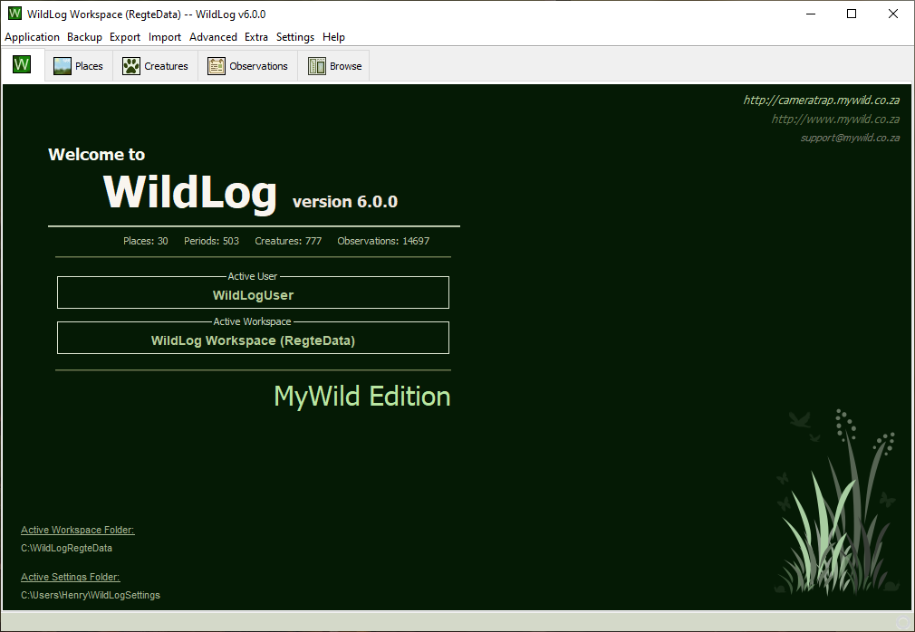

Creating and Changing Workspaces

You can switch to a different Workspace by using the Application menu. A new Workspace will be created at the chosen location if one doesn't already exist. Workspaces can be identified by the workspace.wildlog file inside the Workspace’s folder.

Progress Bar

The progress bar is located at the bottom right hand corner of the screen and will become active during long running processes in order to provide feedback on the progress of the task.
You can still use the application while the task runs in the background. You can even start more than one task at once. It is not recommend to exit the application while tasks are still busy.

Menu Overview

- The Application menu allows you to rename, create and switch active Workspaces. You can also exit the application from this menu. The Check and Clean the Workspace command will validate and improve the health of your Workspace.
- The Backup menu provides options to help backup your database and Workspace. There is also an option to restore a previously backed-up database.
Note: A backup of the database alone will not include the images and other files. To backup all the Workspace content either make a copy of the Workspace or use the “Echo Backup Workspace” or “Backup Workspace” options to make a copy of the Workspace for backup purposes. (Or simply manfully copy the Workspace yourself.)
- In the Export menu you can export the data to XLS, CSV or XML format. The HTML and KML formats will include thumbnail images. The result of the operation can be found in the '[WildLog Workspace]\Export\..' folder. You can also export a part of your Workspace to a new Workspace. The WildNote export will be covered in more details later in this document.
Note: Some exports can take a long time to complete if you have lots of data and files.
- The Import menu item allows you to import data into your database or Workspace from CSV files (same format as the export). You can also import data from another Workspace. The iNaturalist, IUCN and WildNote imports will be discussed in more details later in this document.
Note: Some imports can take a long time to complete if you import lots of data.
- The Sync menu allows you to store and synchronize the workspace on the cloud.
- The Advanced menu helps manage existing data or incorporate newly added data into your database by merging Creatures and moving Periods to new Places. This menu also enables you to update all Observations' Sun and Moon Phase as well as Durations automatically. You can also reduce the size of the Workspace by resizing the image files.
Note: It is recommended to backup your Workspace before using any of these features.
- The Extra menu allows access to some useful features not directly linked to the active Workspace. For instance you can view the EXIF Metadata of any JPEG file on your system, create slide shows of any image folder or view the Sun and Moon phase for any GPS location. It also includes a tool to convert between GPS, Pentad and QDGC coordinates. A System Monitor tool is also available for monitoring resource usage and investigating performance issues.
- The Settings menu allows you to change your preferences for the active Workspace. See the section about Settings below for more details.
- The About menu provides some technical information regarding the current Workspace and version of WildLog and what version of WildNote is supported.
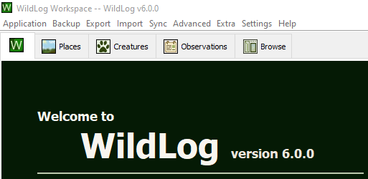

Settings Overview

From the settings menu you can configure the following preferences:
- Map
  - Set Offline Map Start Position
    - You can specify default GPS coordinates where the offline map will be centered.
- Slideshow
  - Set Slideshow Image Size
    - The size that will be used for the generated slideshow’s images.
  - Set Slideshow Speed
    - The speed at which the photos are shown in the slideshow videos and GIFs.
- Performance
  - Show Thumbnails On Tables
    - If this is turned on then all tables will show thumbnails of the default (first) linked file, however this may slow down the application (especially on the first load and older computers). Turning this feature off will result in all tables loading significantly faster, but no thumbnails will be shown in the table.
  - Use Thumbnails On Browse Tab
    - If this is turned off the application will fetch the full size images when you navigate the tree on the Browse tab. Loading many large images can be very slow (especially on older computers). You can turn this feature on to have the application generate a large thumbnail the first time you access a file from the Browse tab. This might be even slower on initial access, but should be much faster on subsequent access.
- Other
  - Use Scientific Names On Tables
    - If this option is enabled then the Scientific Name will be shown in tables instead of the Other Name of the Creature.
  - Enable Beep Sounds
    - With this turned on the application will generate beep sounds during some commands to improve the user experience. If you don't want to hear the sounds you can turn them off using this setting. (Note that this will only turn off sounds generated by the WildLog application. Your computer may still generate beep sounds outside of WildLog's control.)
  - Include Number of Individuals in the File Path
    - If this feature is active the Files stored in the Workspace will include the Number of Individuals.
  - Automatically Upload Error Logs
    - When this option is selected WildLog will periodically try to upload the error logs to a central server. These logs are used to identify possible bugs to be fixed in future versions.
  - Use Bundled Media Viewers (if available)
    - If this option is selected and the WildLog installation has bundled Media Players, then WildLog will use those applications to open image and video files. If you prefer to use your default Media Viewers then simply disable this option.

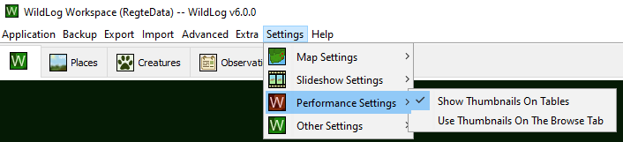

Browse Tab

The Browse tab enables you to easily browse your data. You can view a text summary of the selected node, as well as see the linked files.

Right clicking on a node will open a menu that enables easy access to the maps, reports and exports for the selected node. The menu also provide options to View or Delete the node.

The By Places, By Creatures and By Date radio buttons will change the way in which the data in the tree-list is loaded.

If you want to edit a selected node then you can click on the View button at the bottom left hand corner of the screen. Clicking on the Reload Tree button will reset the data in the tree-list.

The buttons at the top of the image-box operate on the selected node's files. Files can be added and removes. Images can be zoomed in and out. The crop and rotate actions will change the original file. The image meta-data (EXIF data) can be viewed for the active photograph and the original file can be opened by your system's default editor or copied to the clipboard.

The Set as First button will make the currently active file the first file for the selected node.

It is often very useful and convenient to give unique images for each Place, Period and Creature. When browsing an Observation you might want to associate the photograph with the Creature as well. One way to do this is by using the Set Creature File button. This will make the currently active file the default for the related Creature. Places and Periods can be edited in a similar way, using the provided buttons.

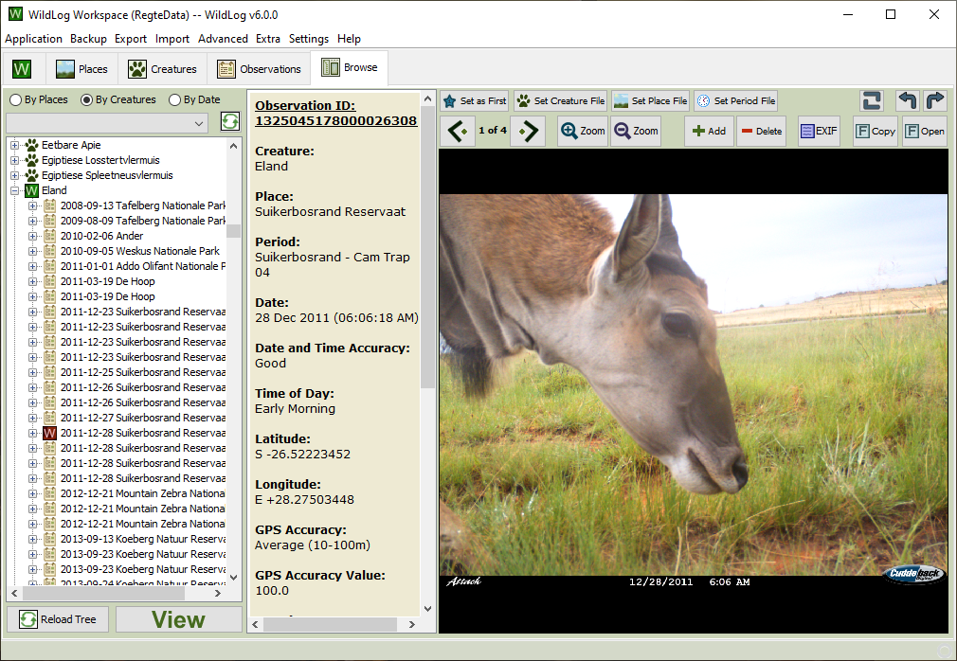

Places Tab

The Places tab allows you to view, add and delete Places. It also shows linked Periods and Creatures for the selected Place.
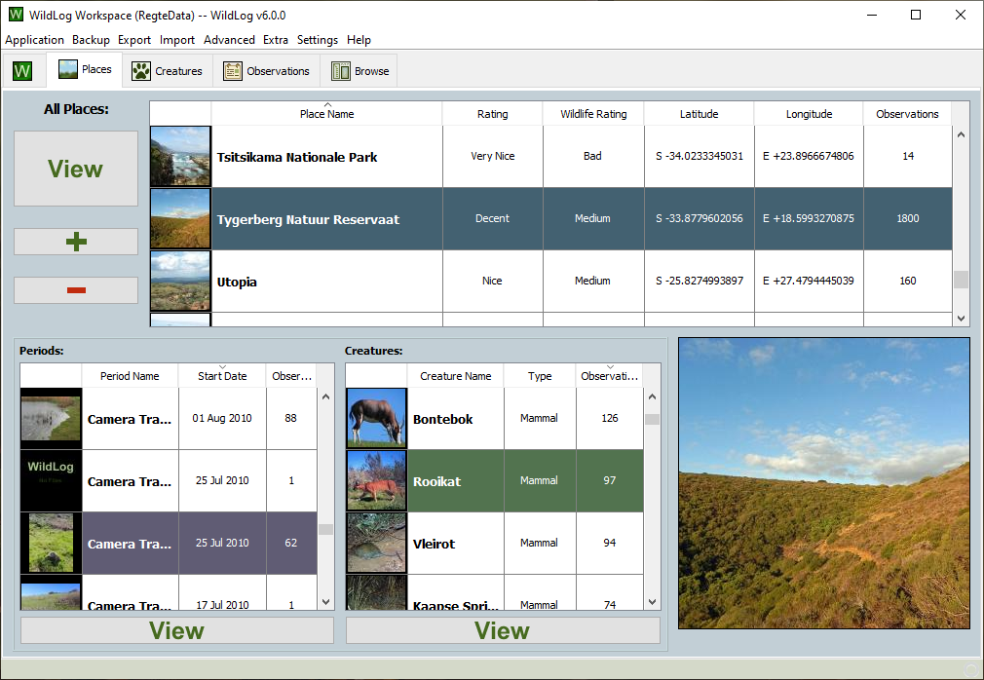

Creatures Tab

The Creatures tab allows you to view, add and delete Creatures. It also shows linked Places for the selected Creature. You can also search for a Creature Name or Creature Type.
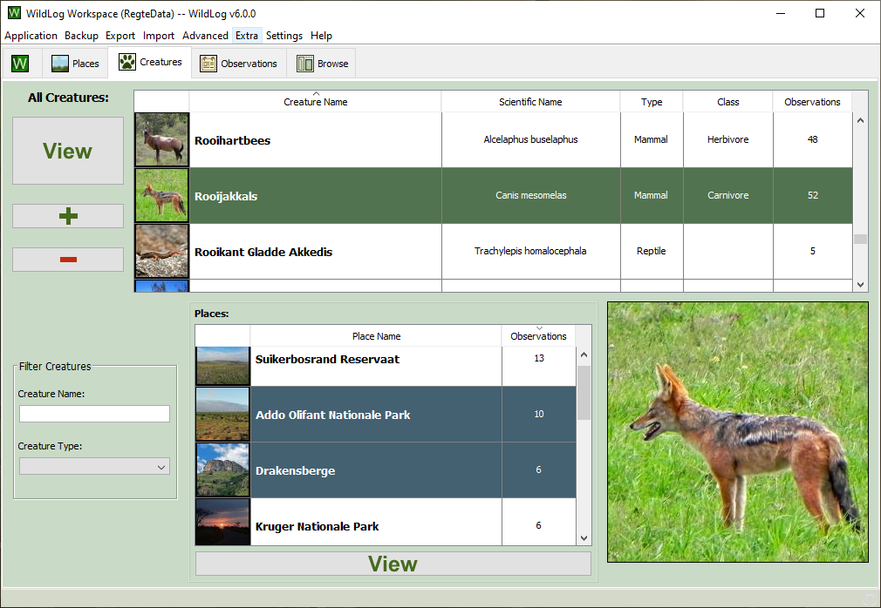

Observations Tab

The Observations tab will allow you to easily select a subset of Observations to view, add or delete. You can open the related Place, Period or Creature, view maps and reports, and export the Observations.

You can change what Observations are shown by using the Observation Filters. By default only recently recorded Observations will be shown. See the Observation Filters section for more information about the various available filter.

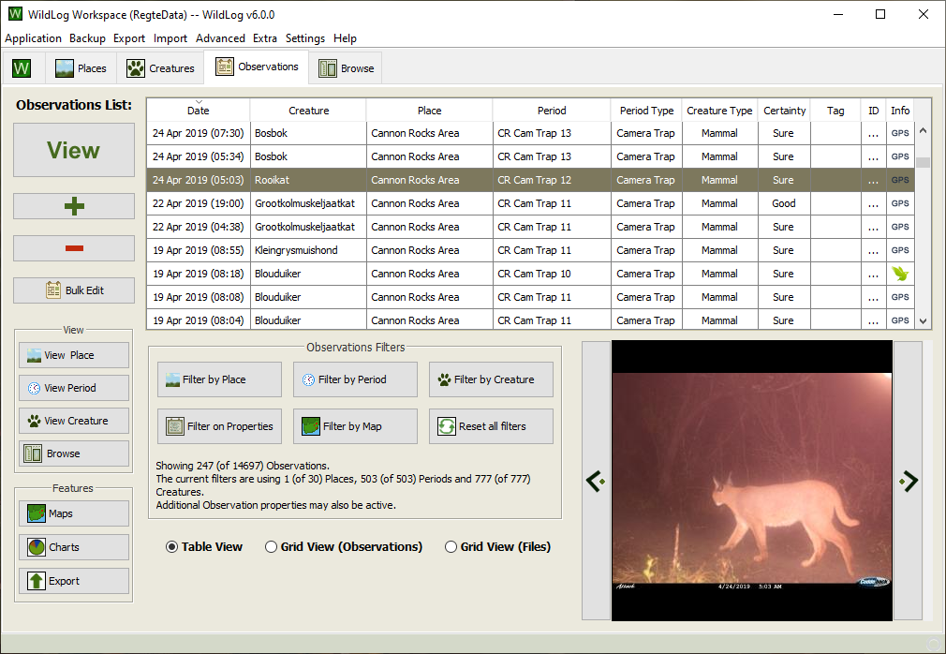
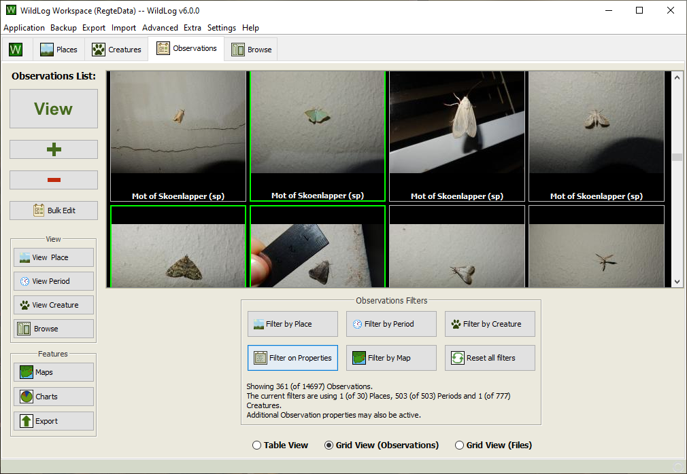
Observations that have been uploaded to iNaturalist will be marked with a small iNaturalist icon under the Info column.

By default the Table View will be used, but the Observations can also be shown in a Grid View.

Note: Observations might take a long time to load for the first time when using the Grid View, because the thumbnail images will need to be generated. Subsequent views should be much faster.

Place Details Tab

Each Place will be opened in it's own details tab. The details tab allows you to view and edit the Place's fields. There are also additional buttons that provide easy access to supported features, such as maps, reports and exports.

You can also open up a Bulk Import tab that will import files for the selected Place.

The Sun and Moon button will allow you to see the predicted sunrise, sunset, moonrise, etc. times for the selected Place and date.

Pressing the Browse button will open up the Browse tab and automatically select the Place in the tree-list.

Using the Place and Period radio buttons at the bottom of the table will switch the content of the table to reflect the selected value.

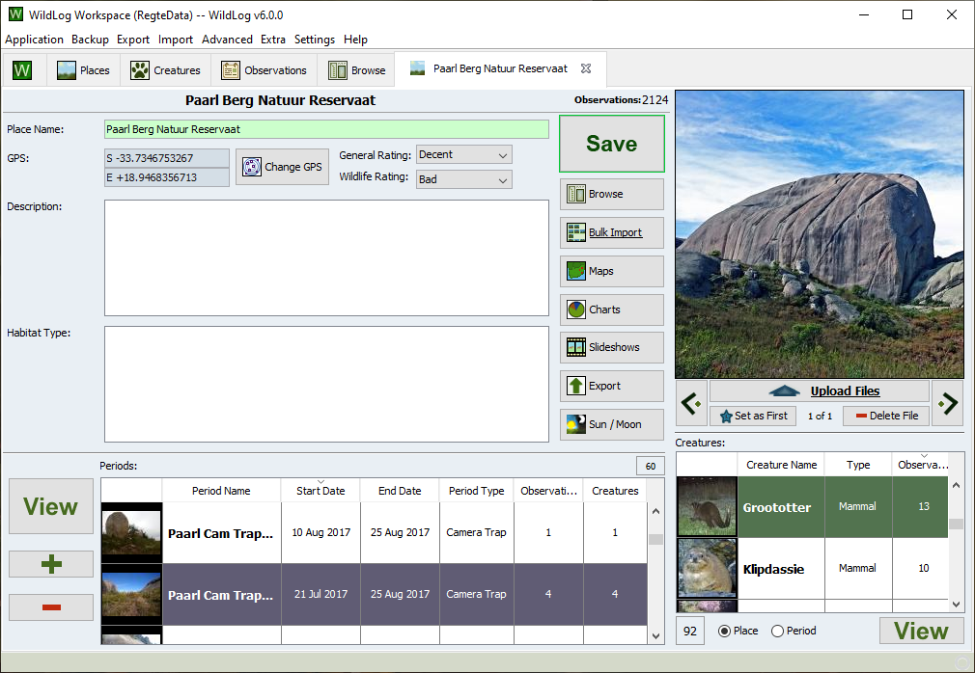

Period Details Tab

Each Period will be opened in its own details tab. The details tab allows you to view and edit the Period's fields. There are also additional buttons that provide easy access to supported features, such as maps, reports and exports.

You can also view, add and delete Observations from this tab. When editing or adding a new Observation a pop-up will appear that allows you to enter the relevant information.

Pressing the Browse button will open the Browse tab and automatically select the Period in the tree-list. The View Place button will open up a tab for the Place to which this Period belongs.

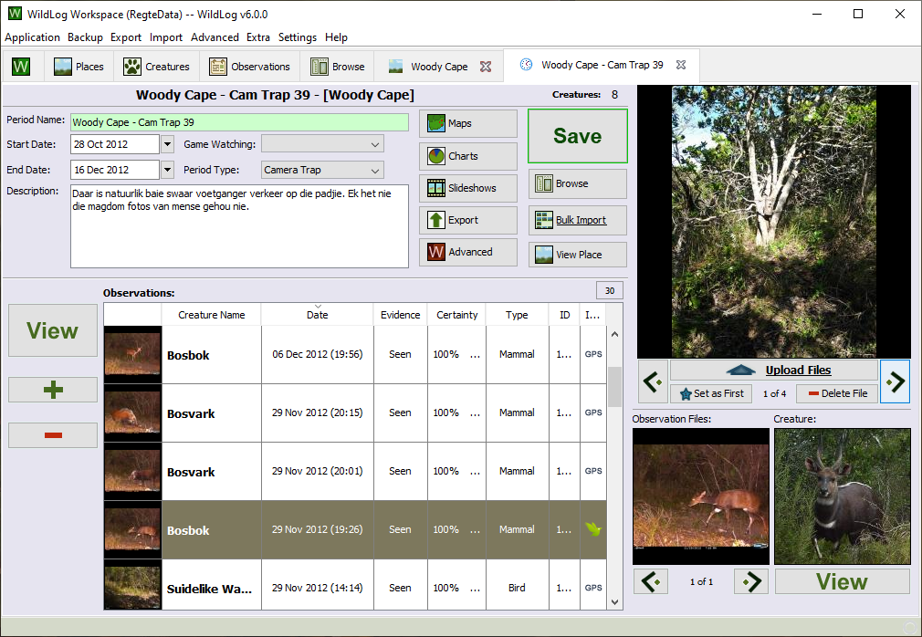
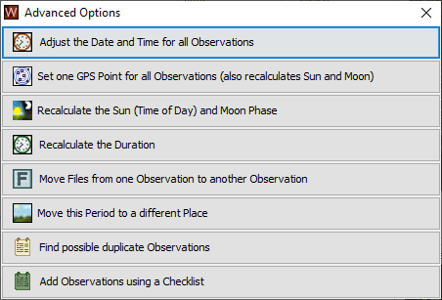

The Advanced button will open up a pop-up with advanced features that usually operate on many Observations at once.

For example you can easily change the Time, GPS, Duration, Sun/Moon Phase or Date/Time for all the Period's Observations.

Observation Details Dialog

Each Observation will be opened in a new pop-up dialog. The pop-up will allow you to view and edit the Observation's information. There are also additional buttons that provide easy access to useful features, such as calculating the duration of the Observation based on the uploaded files, or automatically completing the sun and moon phase using the provided date and GPS location.

To save any Observation it is required to first fill in at least the Date, Creature, Place and Period. It is also highly recommended to provide a GPS location and time as well. Many of the more advanced features in WildLog rely on having the time and GPS data available.

If the Creature, Place or Period you want to add an Observation for is not already in the table, then you can easily add a new entry (from the Observation pop-up) by using the plus (+) buttons at the top of the relevant tables. This will open up another pop-up that can be used to create the new entry.

You can use the search boxes above the tables to get quick access to the row you are interested in.

One Observation can only have one Creature, Place and Period linked to it. If you would like to link an Observation to more than one Creature, then you will need to create a new Observation instead.

The Link with iNaturalist button opens up a popup window to manage the Observation’s integration with iNaturalist.

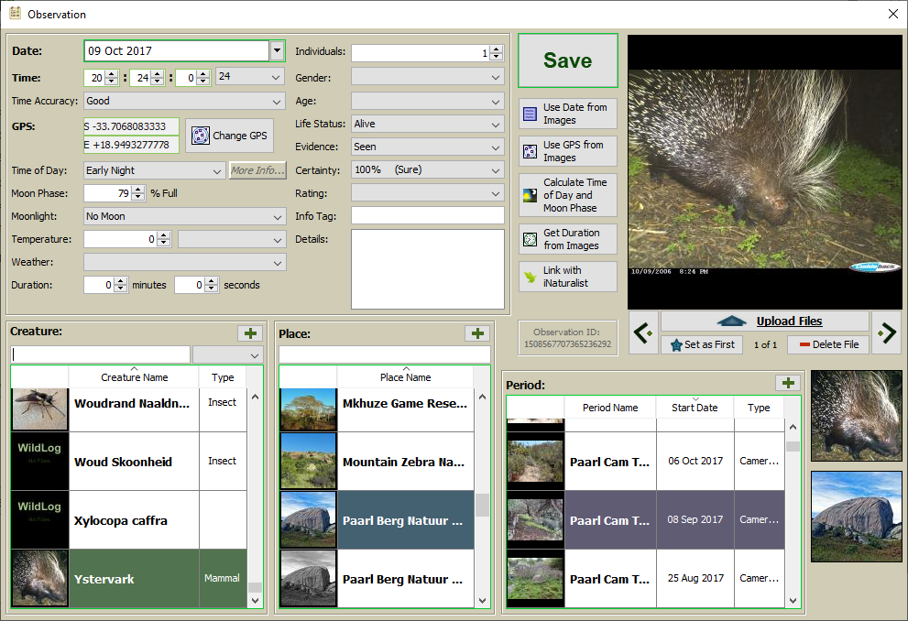

Creature Details Tab

Each Creature will be opened in it's own details tab. The details tab allows you to view and edit the Creature's fields. There are also additional buttons that provide easy access to supported features, such as maps, reports and exports.

You can add a new Observation for the Creature directly from the tab using the Add Observation button to open up a new Observation pop-up.

The IUCN button will use the provided Scientific Name to try and load either the Threat Status (Red List Category) or main Common Name from the IUCN web services.

The iNaturalist button will open the corresponding species page on the iNaturalist website.

Pressing the Browse button will open the Browse tab and automatically select the Creature in the tree-list.

Using the Place and Observation radio buttons at the bottom of the table will switch the content of the table to the reflect the selected value.

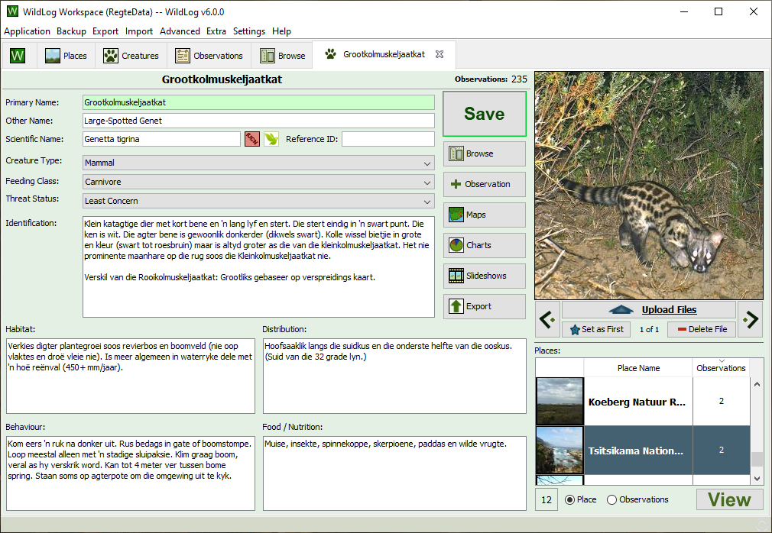

Bulk Import Tab

The Bulk Import tab can be opened from either the Import menu or the various Bulk Import buttons. The Bulk Import tab allows you to quickly process multiple related Observations. You must select the Place at which the Observations where made and then assign a Creature to each Observation. You can specify the Period’s name, type and dates range.

During the Bulk Import process WildLog will automatically group related images into the same Observation based on the amount of time that passed between the photographs. You can then edit the results and press Save to create a new Period with the specified linked Observations.

Accessing files on the computer is a resource intensive process for any application and processing multiple large files at once can take some time. A progress bar will appear at the bottom right hand corner of the application to provide feedback.

You can change some settings to fine-tune the process and then press the Reload button to apply the new settings. This will reload all data, undoing any work you have done thus-far.

You can quickly assign a Creature and GPS location to each Observation using the Creature and GPS buttons. You can edit the full Observation record using the Edit button. The Number of Individuals and Sex can be specified easily without editing the full Observation record.

Files can be moved between Observations using the up and down arrow buttons. Files can be removed using the Remove button, and duplicated among Observations using the Duplicate button. The Observation button will create a new Observation from the selected file. The magnifying glass button will show an enlarged version of the image as a pop-up.

Tip: Hover the mouse pointer over the underlined buttons to discover convenient shortcuts!

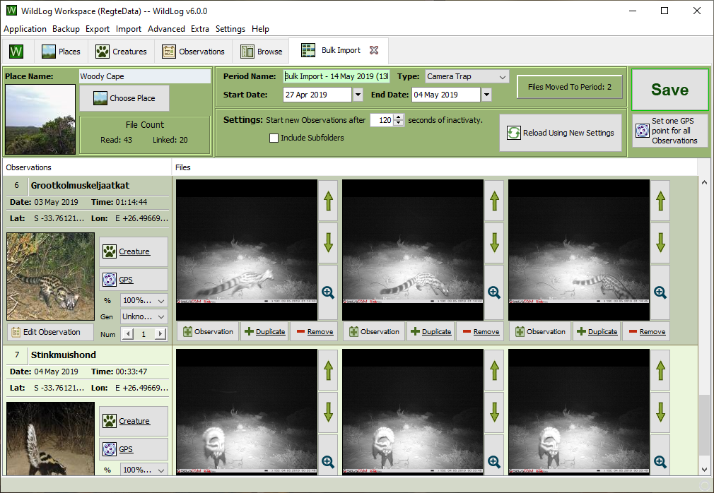

Workspaces

Workspace Data And Uploaded Files

The WildLog application's own files can be installed to the directory of your choice (usually in Program Files), but only the application's own files are stored there. The actual data you import into the Workspace are stored in the Workspace's folder (normally 'C:\WildLog\', but this can also be changed). The Workspace is where the database is stored and also where your uploaded files are saved. Database backups and data exports are also stored in the Workspace's Backup and Export folders respectively.

Thus the Workspace folder basically holds all of the user's WildLog related information and the application's folder holds the files required to run the WildLog application.

WildLog uses a WildLog Settings folder (normally found at '[userhome]\WildLog Settings', but this can also be changed) to store the location of the current default Workspace. The error log is stored in this folder, as well as some temporary files WildLog might need to create.

Insuring Workspace Integrity

Do not remove, rename or edit anything in the Workspace folder (including the folder itself) from outside of WildLog. However, it is safe to remove the files in the Export, Thumbnails, Maps and Backup folder, but none of the other files or folders should be changed (renamed, added, deleted, etc.). Any changes to the Data or Files folder can result in corrupting the Workspace.

Always safely exit WildLog by closing the window or using the Application menu. Interruption of normal program execution may result in a corrupt Workspace.

When the Workspace is on a removable or network drive make sure to always exit WildLog correctly before removing the drive. Premature removal may corrupt your Workspace.

Creating And Changing Workspaces

As described above, all your data is stored in a Workspace folder. You can change the active Workspace or create a new one by using the Application menu. You can also check and clean the Workspace folder by selecting the option from the same Application menu.

Opening One or More Workspaces

A Workspace can be accessed by multiple instances of WildLog at the same time. You are also able to have two different Workspaces open at the same time.

Problems Opening A Workspaces

If you experience problems opening your Workspace then it might be as a result of WildLog not shutting down correctly or that the Workspace folder might be corrupt (or unavailable). You may be able to fix the problem by making sure the Workspace contains a Data and Files folder. If the “wildlog.lock.db” file is present in the Data folder delete it and then try to open the Workspace again, or try to restore the latest database backup.

If you still can't open the Workspace please contact support@mywild.co.za for assistance.

Backup And Restore

The easiest way to backup your Workspace is to make a copy of it. Make sure to exit the WildLog application before making the copy. It is recommended to periodically copy the Workspace to an external drive for safekeeping.

You can also backup your database and Workspace from the Backup menu. The Backup Database option will make a backup of the database. The backup file will be stored in the Backup folder of the Workspace. Note that this will only backup your database, not the uploaded files.

If you need to restore the data from one of the backup versions simply use the Restore Database menu option from the broken or new Workspace. You can also copy the database file “wildlog.h2.db” / “wildlog.mv.db” from your Backup directory into the Data directory. Advanced users can also run the provided SQL script on a new database.

The entire Workspace, including the uploaded files, can easily be backed-up by simply making a copy of it. The Echo Backup Workspace command from the Backup menu is a good way of doing this. The Backup Workspace command can also be used to easily create a full (or partial) backup of the Workspace by exporting it. This export can then be stored for backup purposes.

Backed up Workspaces can be accessed in the same way as any normal Workspace, and thus doesn't need any special action to “restore” it when you have the need to roll back to a previous backup.

Export

You can export the data as:
- SQL
- XLS
- CSV
- XML

Additionally you can export the data and files as:
- HTML
- KML
- XLS (Paarl Reserve Format)
- New Workspace

The exports available form the Export menu and the various Export buttons.

The CSV export is useful for viewing and integrating with external applications such as Excel or ArcView.

The HTML export provides an overview of all information as a web page that can be viewed offline in your default web browser.

The KML export can be opened by mapping applications such as Google Earth.

All exports can be found in the Export folder of the Workspace.
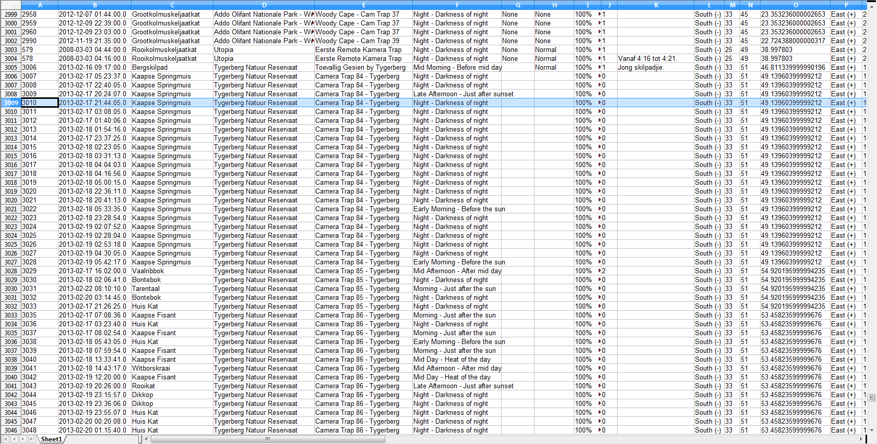
Example: CSV Export

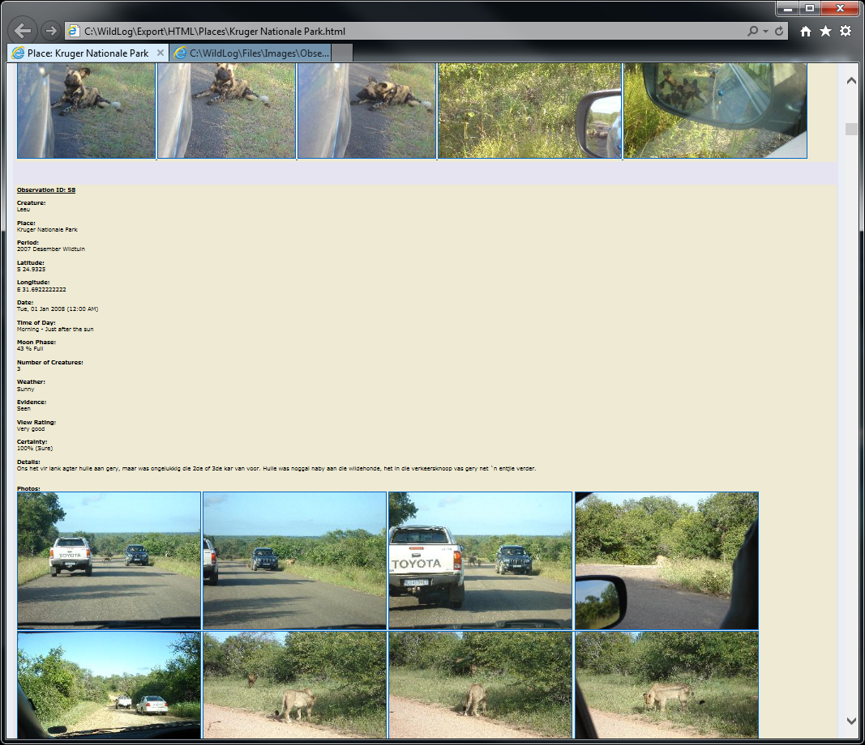
Example: Basic HTML Export

Import

It is best to backup your entire Workspace (or at least your database) before running any of the features in the Import menu.

Import From CSV

Currently you can only import CSV files that are in the same format as the files generated by the CSV export process. Please backup all your data before starting the import process.

When using the WildLog format to import, conflicts can be either automatically resolved or you can manually choose which record to keep during the import process.

It is recommended not to import any files using this method, but if the option is selected to import the database references to the files as well, then the user must also manually make sure that the relevant files are correctly copied to the Workspace's Files folder. (If you want to import the files as well, then it is recommended to use the Workspace import instead.)

Import From IUCN Species Lists

It is possible to import species common names, scientific names and threat status from a CSV file available from the old IUCN Red List website. You will have to download the file containing the data you wish to import from the IUCN website and then import it using the command from the Import menu. The IUCN import process provides options to fine tune which records should be added or updated.

Import From Another Workspace

Data and uploaded files can be imported from another Workspace.

Conflicts can be either automatically resolved or you can manually choose which record to keep during the import process.

Import From WildNote

WildLog can import data that was captured using WildNote.
See the WildNote Integration section for more details.

Bulk Import

WildLog will automatically group all images in the specified folder into Observations and allow you to easily assign Creatures, GPS coordinates, a Place and a Period to the Observations.
See the Bulk Import Tab section for more details.

Import From iNaturalist

WildLog can import data that was originally captured on iNaturalist.
See the iNaturalist Integration section for more details.

Advanced Features

It is best to backup all of your data before running any of the features in the Advanced menu.

The Advanced menu provides features to update multiple records at once, but most importantly it allows you to easily move and merge existing Creatures, Places and Periods by coping all of the relevant Observations from one record to the other and then deleting the initial record.

Please see the menu options section and the menu item tool-tips for more details.

Slideshow Videos

WildLog can generate slideshows that show a list of images one after the other. These slideshows provide an easy way to view all the images for a Place, Period or Creature and can be created in various formats.

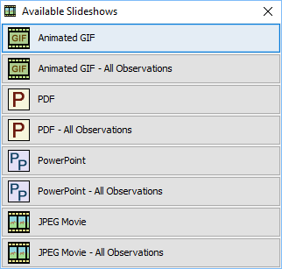
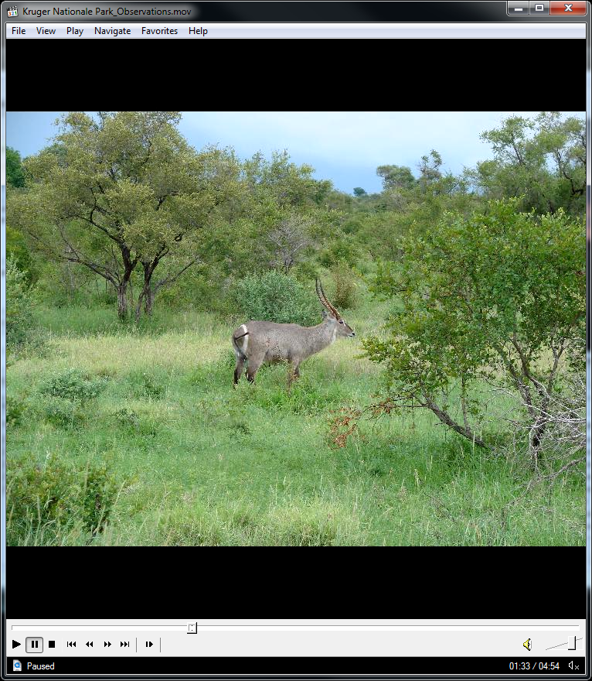
For the Animated GIF and JPEG Movie options the duration for which an image is shown can be configured in the Settings menu.

The resolution (size) at which the images are generated can also be configured in the Settings menu.

Once the slideshow has been processed (see the progress bar for feedback) it will be opened by your system's default viewer.

Maps

WildLog comes with a large number of built in maps. The maps are accessible throughout the application. The maps use the Observation records to generate the GPS points on the map.

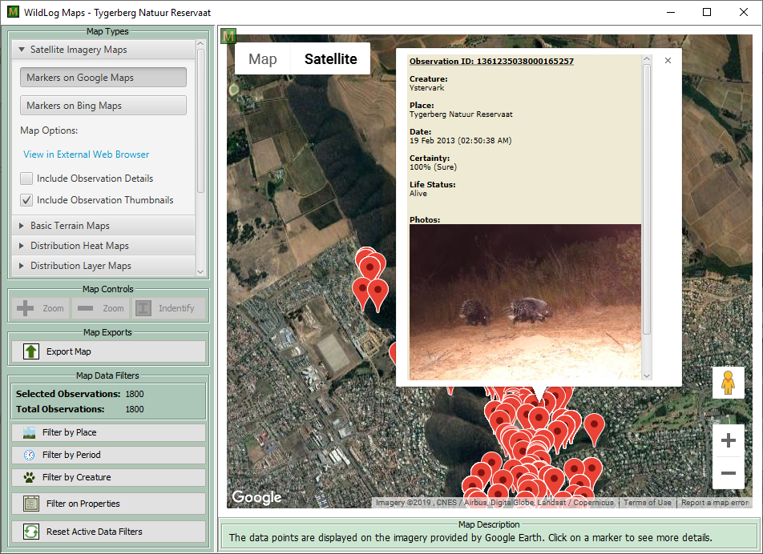
Different maps can be selected from the Map Types section. A description of each active map is provided at the bottom of the screen in the Map Description section.

Some maps can be interacted with by clicking on the GPS markers.

There are both online (requires an internet connection) and offline maps available.

Maps can be exported to various formats. The results of the export will be available in the Workspace's Export folder.
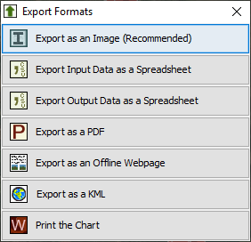
The KML export can be opened in an external KML viewer, such as Google Earth.
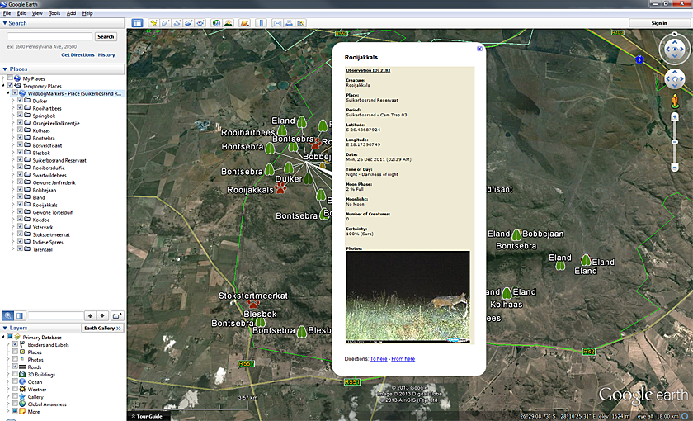
The CSV exports also provides a convenient way of accessing the geo-spatial data in your Workspace. External tools, such as ArcGIS or ArcView, can use the GPS coordinates provided in the CSV file to show the data on the external map.

Distribution and Heat Maps

WildLog can plot the active Observations on a map to show the general distribution of the Creature. These maps are based on the Scientific Name field of the Creature record.

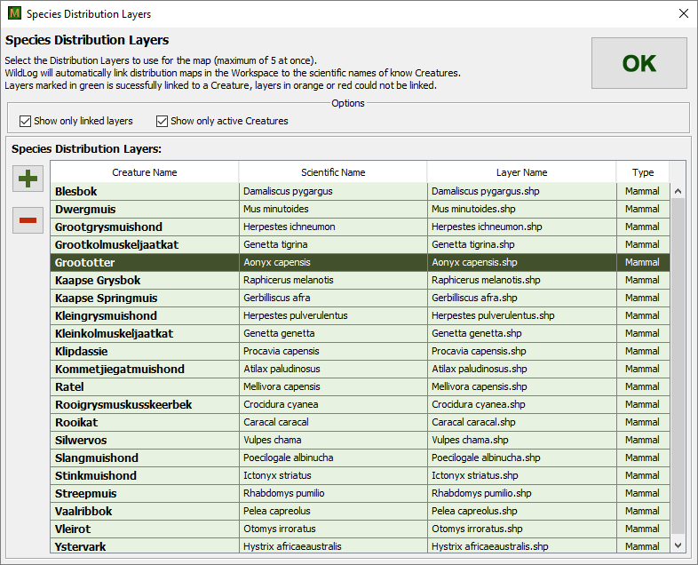
When adding new layers to the Workspace the files will be copied to the Maps\Species folder as shown below.
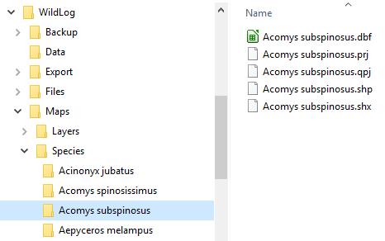
The application will then be able to automatically detect the layer in the future.

WildLog can plot your own Observations on top of the selected distribution map for comparison.

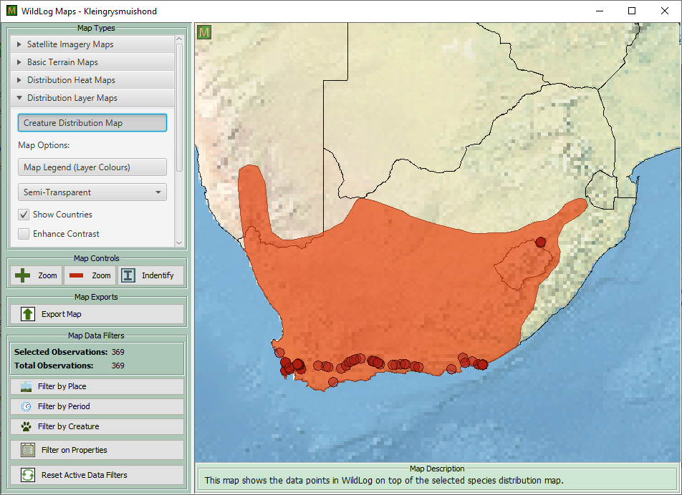

Note: The distribution shapefiles for many species can be downloaded from the IUCN's website. However, additional processing may be required to split the file provided by the IUCN into separate files for each species.

Online heat maps can be generated to help visualize high or low concentrations of Observations. The transparency and radius can be adjusted to improve the visualization.
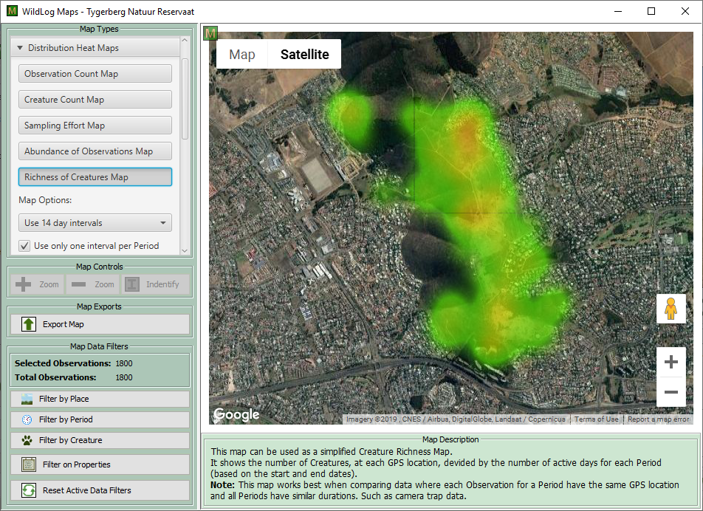
WildLog can also try to fetch occurrence records from online data sources. Currently only GBIF and iNaturalist data is used (requested via online web service calls).
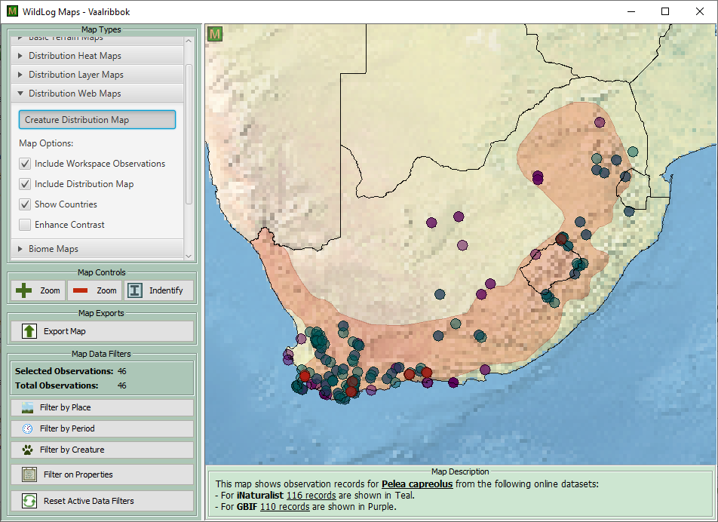

Features on the offline maps can be identified by using the Identify button.

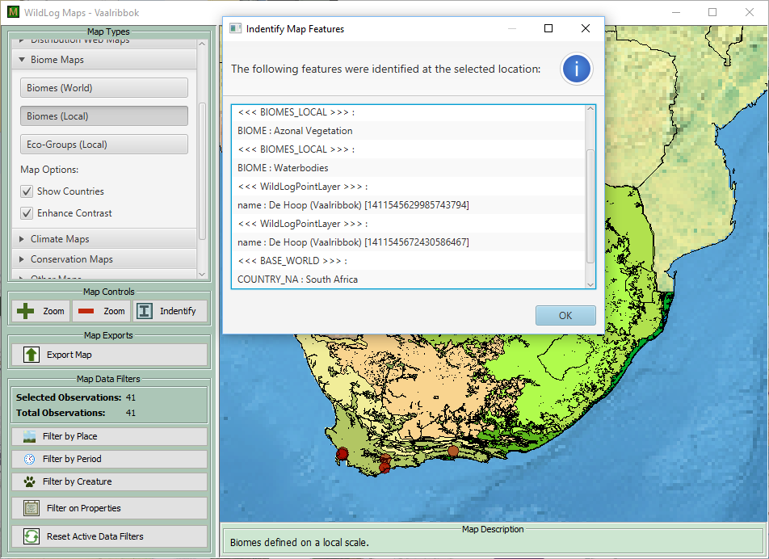

Custom Layers

Similar to the Distribution layers you can also upload external GIS layers into the Workspace using the Custom Map Layers dialog. The layers will be stored in the Workspace's Maps\Custom folder. The dialog is also used to select which layers to display.
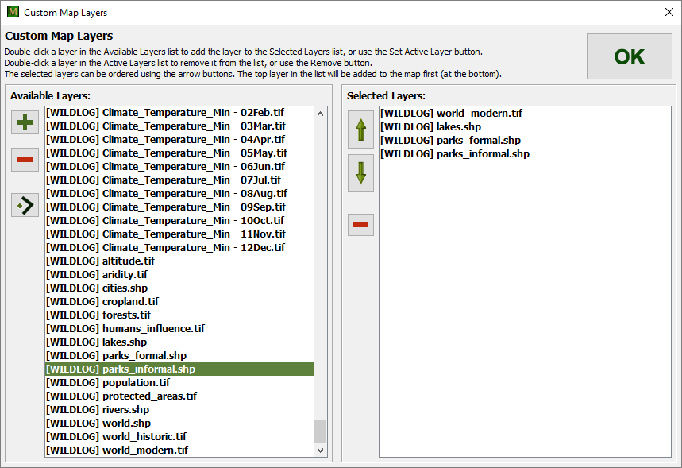
A legend is available which can be used to recolor the layers.

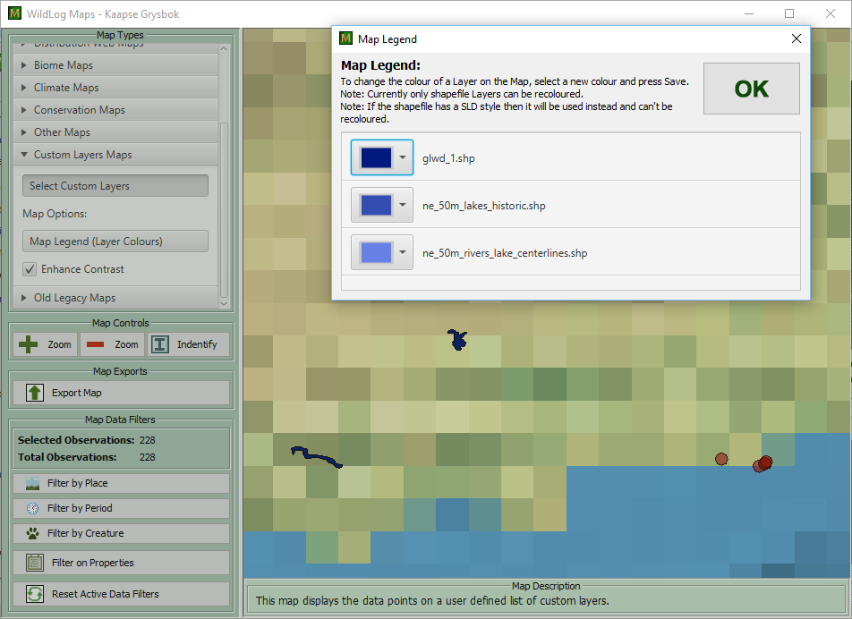
All active Observations will be automatically included on the map as red circles.

Charts

WildLog comes with a large number of built in charts. The charts are accessible throughout the application. The charts use Observation records to generate various useful charts.

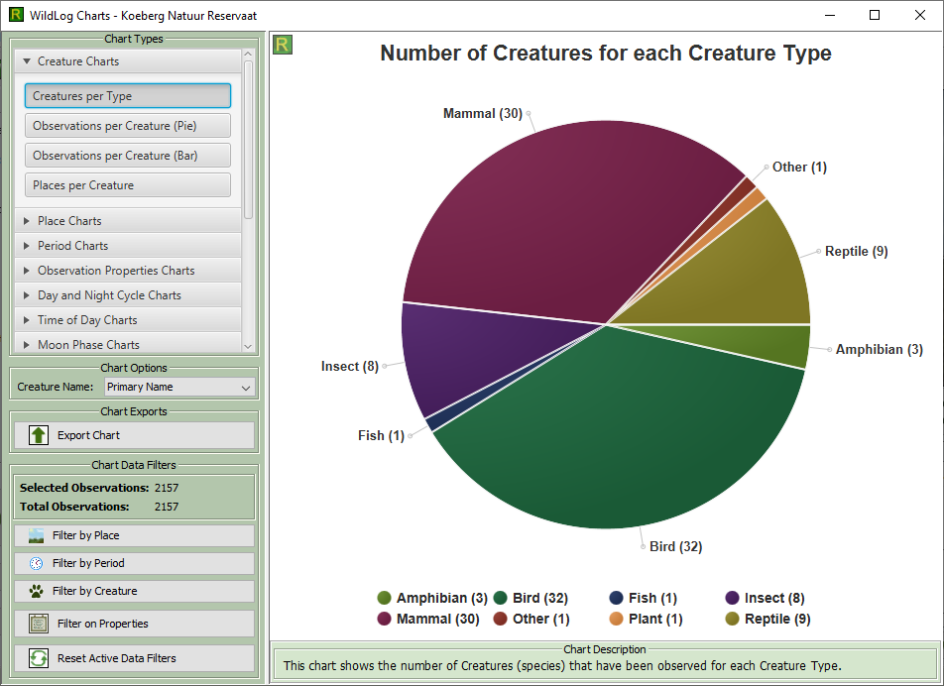

Different charts can be selected from the Chart Types section. A description of each active chart is provided at the bottom of the screen in the Chart Description section.

Charts can be exported to various formats. The results of the export will be available in the Workspace's Export folder.
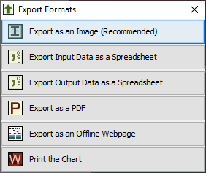
Most charts will show additional information about the data point when clicked on.

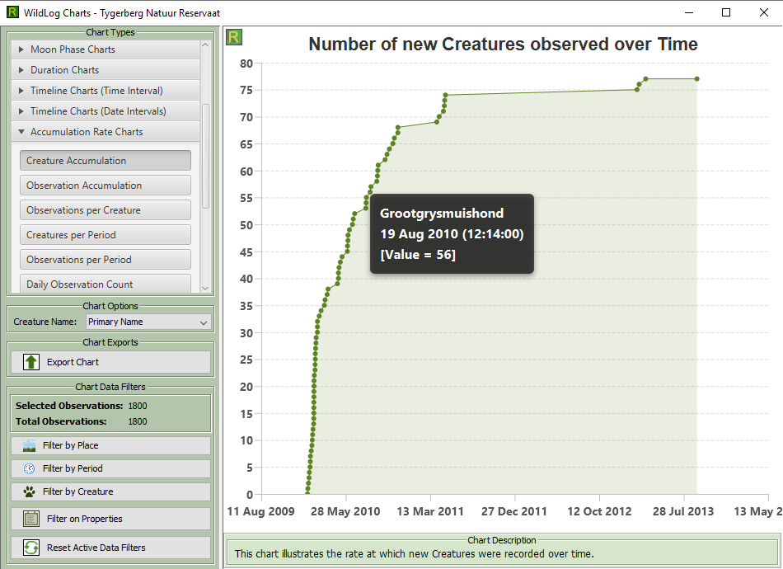

It is also possible to choose which language to use for the Creature names in the charts.

Observation Filters

The Observation Filters can be used to include or exclude Observations from charts, maps and the Observation Tab. Pre-configured property filters can be saved to be reused easily in the future.

Note: You may run into performance problems when trying to work with too many active Observations at a time, if this happens try to reduce the amount of Observations using the these filters.

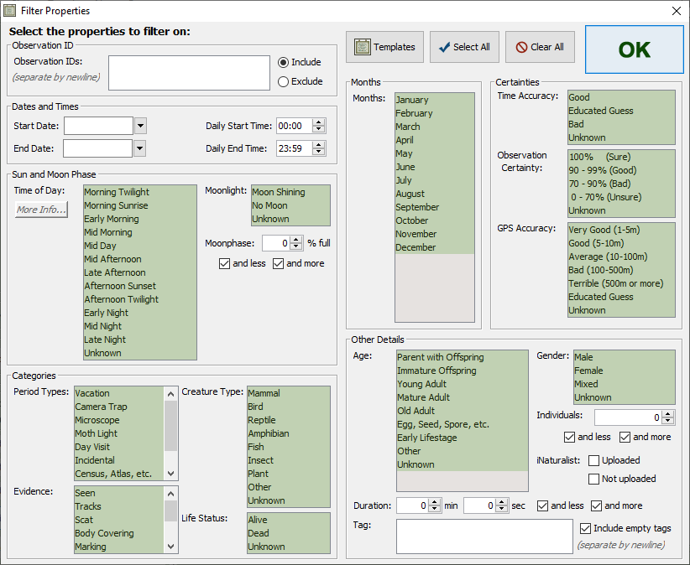
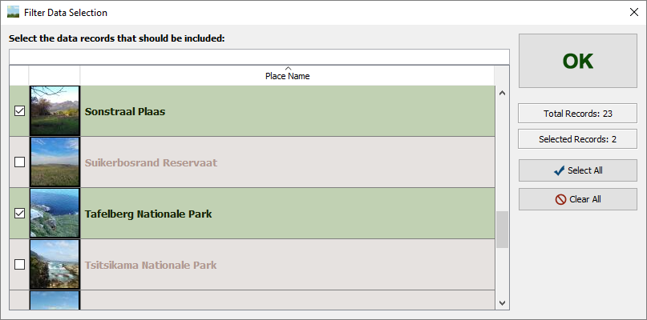

Sun and Moon Phase
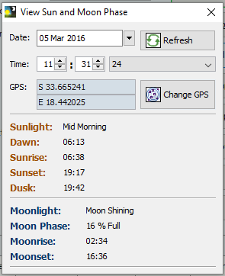
In order to calculate the sun and moon phase the date (including time) and GPS coordinates must be know.

WildLog can automatically calculate the sun and moon phase for an Observation when doing a Bulk Import, uploading files to an Observation, pressing the Calculate Time of Day and Moon Phase button on the Observation pop-up and lastly by selecting the feature to update all Observation's sun and moon phase via the Advanced menu.

It is also possible to see the current sun and moon phase for any Place by simply clicking the Sun and Moon button on the Place's details tab.

This feature is also accessible from the Extra menu when you would like to know the sun and moon phase for an arbitrary location.

Extra Features

WildLog also provides some “stand alone” features that can be accessed from the Extra menu.

These tools aren't for normal use, but might facilitate the needs of more advanced users.

There is a tool that will display all the EXIF Meta-data from any JPEG file on your system. You can also generate Slideshows (video and GIF) for files outside the WildLog Workspace folder. There is also an options to get the sun and moon phase estimates for any GPS location and time.

The Convert GPS / Pentad / QDGC dialog can be used to covert between these coordinate systems.

The System Monitor can be used to visualize the load on the system, or to generate system snapshots that can be used to investigate performance problems.

The H2 SQL database's browser client is also easily accessible from this menu. (You can log into the WildLog database using the user name wildlog and password wildlog.)

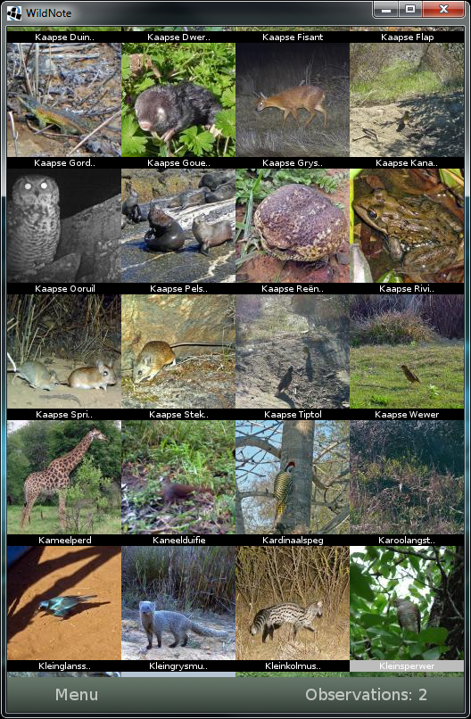
WildNote Integration

Make sure to use the correct version of WildNote with a particular version of WildLog. Use the Help menu to see the needed version information.

WildNote is an Android application being developed by myself to provide an easy interface for capturing Observation records from a mobile device and then importing the records into WildLog.

WildNote is still in very early development and haven't been tested on many devices. Some features are still missing or not very user friendly, but usability and features will improve as development continues.

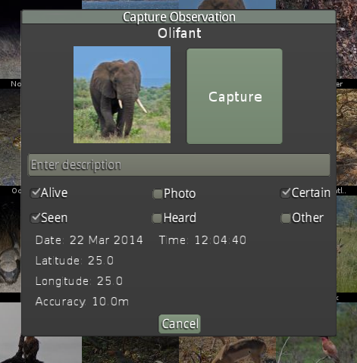
In order to capture Observations using WildNote you will need an Android device with a GPS. Make sure the GPS is enabled before starting WildNote. The GPS chip on some mobile devices can be very weak and may take a very long time to get the first fix. It is recommended to keep the GPS on and WildNote running while you are busy capturing Observations.

WildNote provides a grid of Creatures that can be selected to open up a confirmation pop-up that allows you to capture an Observation for that Creature.

Captured Observations can be edited by accessing the Menu and then selecting the Edit Observations button.

You can monitor the GPS status from the Menu by selecting the GPS Status button.

Export Data From WildLog To WildNote

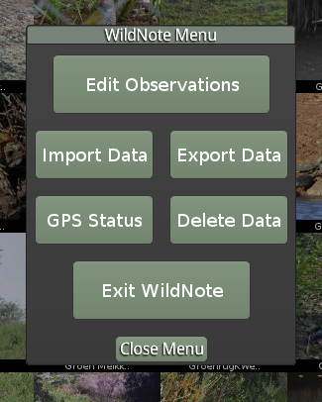
In WildLog select the Export WildNote Sync File option. This will generate a file called WildNoteSync.zip in the Export folder which needs to be copied to the Android device's /WildNoteSync/SyncIn/ folder. (If the folder does not already exist you can do an “empty” import first and then copy the file.) To do the import in WildNote, select the Import Data button from the Menu.

Import Data From WildNote Into WildLog

In WildNote select the Export Data button from the Menu. This will create wildlogSync.h2.db in the /WildNoteSync/SyncOut/ folder. Copy this file to the computer running WildLog. Import the file into WildLog using the Import WildNote Sync File from the Import menu. WildLog will present you with the opportunity to, optionally, also try to automatically link the captured Observations to a list of photos in a folder.

iNaturalist Integration
Observations in the WildLog Workspace can be easily integrated with your iNaturalist account.
First, your iNaturalist account must be linked with the WildLog application. You can then generate an authentication code which will be used when uploading or downloading data.
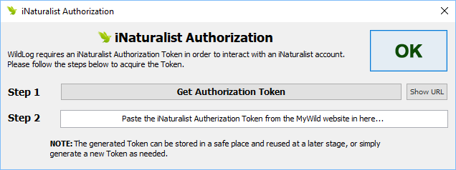
Observations from the WildLog Workspace can be uploaded and then later downloaded from the iNaturalist Observation Details dialog. The downloaded iNaturalist data is stored in the WildLog Workspace’s database for future offline access. The original photograph can be uploaded. Photographs can also be cropped before uploading.
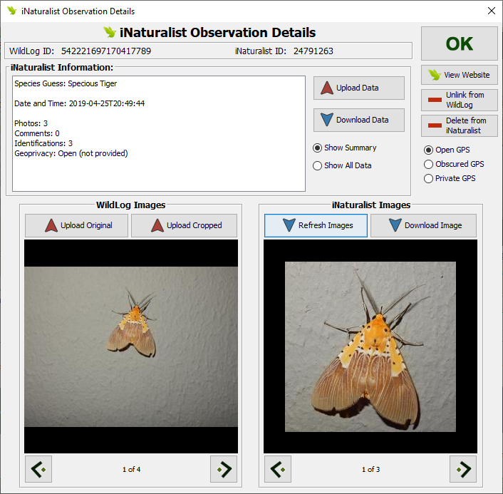
Observations originally captured on iNaturalist can also be downloaded into the current WildLog Workspace.
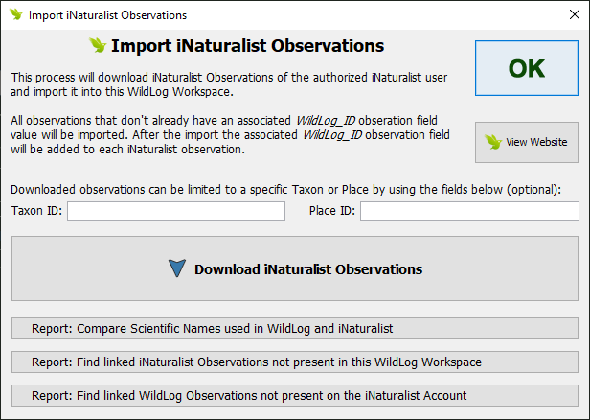
It is also possible to compare the species identification on iNaturalist to the one used in the WildLog Workspace.
On the iNaturalist web site all linked Observations will include the WildLog_ID as an Observation Field.
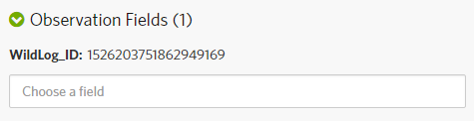

Cloud Sync

The Cloud Sync Workspace process can synchronize the current Workspace with a copy in the cloud. This can be used for backup or to share data between users or devices.

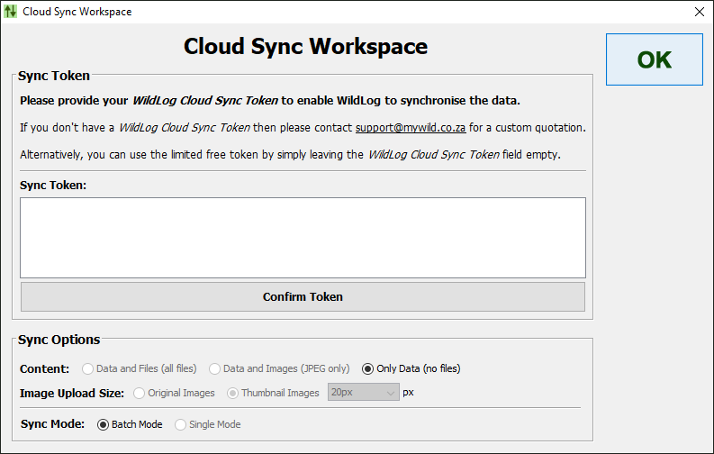
Storing data in the cloud costs money, as a result WildLog provides limited free functionality.

By default only data can be stored, and Workspaces must contain under 1000 records.

A WildLog Cloud Sync Token is needed to unlock more cloud storage.

Please contact support@mywild.co.za if you would like to find out more.

Check And Clean Workspace

The Check and Clean the Workspace feature can be selected from the Application menu. The WildLog application will then start a process to check the health of the currently active Workspace and try to automatically correct any inconsistencies that are detected. This process will make sure that the data is linked correctly and that all files are in the correct folders. All standard thumbnails can also be recreated.

This process can take extremely long. A summary report will be shown at the end. It is important to allow the process to finish without interruption.

It is recommended to run this process after upgrading to a new version of WildLog or after performing any data imports. It is also a good idea to run it after renaming any Places or Creatures.

Because this process can have a huge impact on the Workspace, it is recommended to make a backup (copy) of the entire Workspace before starting the process and to verify the results afterward.

Additional Information

For details on uninstalling WildLog please see the Uninstall Notes.txt file in the application's installation folder.

If you want to run WildLog without installing it, or on a non-Windows operating system then please read the How to run WildLog.txt file in the application's installation folder. This file also shows you how to run WildLog from a portable flash drive without having to install Java.

The Future of WildLog

I like to think about WildLog as a continuous work in progress and I have a long list of functionality I would like to add when I eventually have the time to work on it. If you have any suggestions or found some bugs I would love to hear from you.

Contact Information

You can send an email to me (Henry de Lange) at support@mywild.co.za if you have any questions or experience any difficulties.

Minimum System Requirements

- Supported Operating Systems:
  - Windows XP and later. Windows 10 is recommended.
    - (Tested on Windows XP, Windows 7, Windows 8 and Windows 10.)
  - Any other random Linux flavors with support for Java 8 should also work.
    - (Tested on Ubuntu.)
  - Mac 10.8.3 and later with support for Java 8.
    - (Not tested.)
- Software:
  - Java 8.
    - The default Windows installer of WildLog (the MSI file) comes with Java bundled and does not require an additional Java installation.
    - You can download the latest Java from http://www.java.com/getjava/
      - You only need the Java SE (Standard Edition) version, not the JDK.
- System Memory:
  - Minimum 512MB.
  - Recommended at least 2048MB (2GB).
- CPU:
  - Minimum Pentium 2 266 MHz processor.
  - Recommended to use a processors in the Intel Core or i3/i5/i7 range.
- Hard Disk Space:
  - WildLog itself uses around 100-250 MB.
  - The Java Runtime takes up another 100-200 MB.
  - The WildLog Workspace folders can become massive, easily exceeding 10+ GB if many files are imported. Note that the database itself is very small (1-50 MB), but the images and videos can become very large.
- Screen Size:
  - Minimum resolution of 1024x768 is required.
- Internet Access (Optional):
  - No internet access is required for the application to work.
  - For the built in mapping you can switch between online and offline maps. (The online maps will require a basic internet connection to download the map tiles.)

